February 2020
VOLUME XXVII
ISSUE II
3900 Hollywood Road, St. Joseph, MI 49085 www.bccancerservice.org 269.429.3281 staff@bccancerservice.org

In honor of the committed service of Olove Colcord, R.N.

Newsletter

THE MISSION OF THE BERRIEN COUNTY CANCER SERVICE:
To provide compassionate in home skilled nursing care and supportive resources for those
affected by cancer or related illnesses in Southwest Michigan.

The BERRIEN COUNTY CANCER SERVICE SUPPORT GROUP is a group of patients, family members and caregivers. Come share successes, feelings, fears and practical methods of coping
with the physical and emotional aspects of living with the diagnosis of cancer.

CONTENTS

Bulletin Board/
Upcoming Events…. 2

Art Play Workshops…. 3

Cancer Awareness…. 3

Memorials/Tributes…. 4

Looking Ahead/
Dates to Remember…. 5

Board of Directors,
Nursing/Office Staff…. 6
This is My Wish for You

Comfort on difficult days
Smiles when sadness intrudes
Rainbows to follow the clouds
Laughter to kiss your lips
Sunset to warm your heart
Hugs when spirits sag
Beauty for eyes to see
Friendship to brighten your being
Faith so that you can believe
Confidence for when you doubt
Courage to know yourself
Patience to accept the truth
Love to complete your life

PENNIES FOR PATIENTS DATE ANNOUNCED!!

May 14th 2020 is the new Pennies For Patients Date! Start collecting and stay tuned for details!!!

THANK YOU FOR SUPPORTING OUR MISSION
It is YOU our community that enables us to care for those with cancer and related illnesses in our community. We are grateful for all the support and are honored that you trust us to do our best to provide in home skilled nursing care for our patients and those who need our assistance. A special Thank You to Van's Medical Equipment for picking up, cleaning and delivering our durable medical equipment as a courtesy to BCCS in support of our community!

BCCS Bulletin Board

SAVE THE DATES!!!

PENNIES FOR PATIENTS
May 14th 2020!

Recent Star Givers Include:

Todd and Elizabeth Christy
St. Joseph, MI

Dieter & Agathe Krueger
Stevensville, MI

Patient Remarks

“The lady at BCCS in Stevensville was so compassionate, kind and helpful. Thank you for all you do for this community!”
DID YOU KNOW…

That we love sharing from our loan closet and want to be able to have the items that are needed. Here are the current needs that we have for the loan closet:

  - Shower Chairs with backs
  - Stylish turbans
  - Nutrition such as Ensure® or Boost®
  - Small and Large incontinence underwear
  - Wig supplies (shampoo and conditioner)

Let it Snow, Let it Snow, Let it Snow!

BCCS may be closed for snow days during inclement weather. So, if it is snowing, please call us at 269-429-3281 prior to coming to the BCCS office to make sure that we are open. On the days that the office is closed, the answering machine will be checked periodically. If you have a medical emergency, please call 911. The nurses will still be visiting patients unless the roads are hazardous. Often the nurses will make patient visits a day early if they know that a snow storm is coming.

PENNI

a

Milano’s Pizza in

Be Counted for Berrien’s Fair Share
The U.S. Census Bureau counts each resident every 10 years and 2020 is the year. The Census count is used to get Berrien County’s fair share of federal funds. It’s vital that every one of us be counted. Census-based funding is used for roads, bridges, education, school lunches, Head Start, children’s health insurance, and many more programs.
The Official count day is April 1, 2020. The Census form is short, only 9 questions. It will ask your name, gender, age, birthday, race, ethnicity, phone number, relationship to head-of-household, and owner or renter. By law, individual-level Census information cannot and will not be shared with any agency - not the IRS, sheriff, courts, ICE, DHHS - not anyone, including a landlord.
Based on Census projections, Berrien County is at risk of losing over $44 million per year for 10 years … that’s $440 million due to residents who do not complete the Census form.
What can you do? Talk about the Census with your friends, neighbors and colleagues. Everyone Counts. For more information, go to BeCountedBerrien.org

February is World Cancer
Awareness Month

World Cancer Day is an international day marked on February 4th to raise awareness of cancer and to encourage its prevention, detection, and treatment. Hearing that you have cancer changes your life and the lives of those around you.
Millions of Americans alive today have a history of cancer. For them, cancer has become a chronic on-going health problem, like high blood pressure or diabetes.
If you have cancer, you may notice every ache, pain or sign of illness. Even little aches may make you worry. Its important to focus on living. Try to make the most of each day while living with cancer and its treatment. People respond to cancer in many ways.
Learning you have cancer can come as a shock. For many people, the first few weeks after diagnosis are very hard. People with cancer and those close to them experience a wide range of feelings and emotions. These feelings can change often and without warning. At times, you may: be angry, afraid, or worried, feel out of control, be sad guilty or lonely.
Denial – When you were first diagnosed, you may have had trouble believing or accepting the fact that you have cancer. Usually by the time treatment begins, most people accept the fact that they have cancer.
Anger – Anger sometimes comes from feelings that are hard to show. Such as fear, panic, frustration, anxiety, or helplessness.
Fear and worry – The word “cancer” frightens everyone. It’s a diagnosis that most people fear more than any other.
Pain – The most important thing to remember is that to control your pain, you have to talk honestly with your doctor about it. When it comes to pain, there is no right or wrong answer.
Control and self-esteem – Even though you may feel out of control, there are ways you can be in charge.
Sadness and depression – Sadness is a normal response to any serious illness. Depression is sometimes a serious problem.
Loneliness – You may feel less lonely when you meet other people who have cancer when you join a support group. Some people prefer to talk with just one person at a time.
Hope – Once people accept that they have cancer, they often feel a sense of hope.
You will have many feelings as you learn to live with cancer. These feelings can change from day to day, hour to hour, or even minute to minute.
Feelings of denial, anger, fear, stress and anxiety, depression, sadness, guilt, and loneliness are all normal. So is a feeling of hope. While no one is cheerful all the time, hope is a normal and positive part of your cancer experience.

Although annual (every year) screening should not be done, women who have abnormal screening results may need to have a follow-up Pap test done at 6 or 12 months.
The American Cancer Society guidelines for early detection of cervical cancer do not apply to women who have been diagnosed with cervical cancer, cervical pre-cancer, or HIV infection. These women should have follow-up testing and cervical cancer screening as recommended by their health care team. Adapted from cancer.org

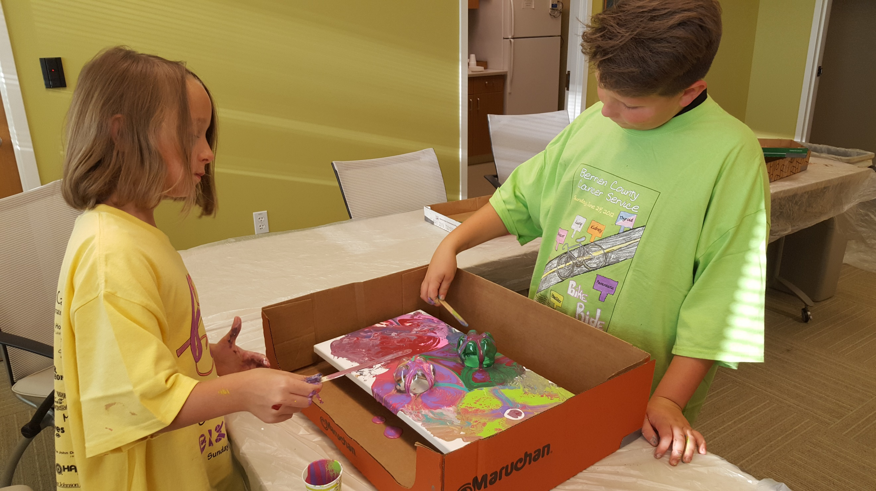

ART PLAY WORKSHOPS

Please note Art Play Workshops are back!

Dates and locations are as follows:

Buchanan Art Center
February 10th from 4:30-5:30 pm

Krasl Art Center
February 20th from 4:30-6:00 pm

These workshops are designed for families impacted by cancer and are designed for children and adults to learn side-by-side as they use clay, watercolor, and other media to express themselves through art. If you know of any children who have a family member or close friend with cancer or are a stable pediatric cancer patient, please have them call 269-429-3281 and ask for Nancy regarding these workshops. You can also find out more information on our website www.bccancerservice.org or on our FB page: Berrien County Cancer Service, Inc.

In Memory of Bonnie Kurbis
Robert Bouchickas, St. Joseph
Mick Klug, Berrien Springs
Starks Family Funeral Homes, St. Joseph
Barbara Shafer, Stevensville
Bernice Tretheway, Stevensville

In Memory of Don Lane
Barbara Lane, Benton Harbor

In Memory of Scott Ross
Sandra Jewell, St. Joseph

In Memory of Lauretta Titman
Kathy Buck and Kevin Preloger, Chicago IL

In Memory of William Whitfield
Jeanette & Dolores Fester, Benton Harbor
Sharon Kallin, Niles

I

In Loving Memory

Memorial Donations were generously
made by and for the following:

In Memory of Adam Tilly
Rebecca Eichler Toth, St. Joseph

In Memory of Dale Kugle
Paulette, Thomas Johnson, Morrice
Jonathan Jaloszynski, St. Joseph

In Memory of Bruce Temple
Ann Temple, Elyria, OH

In Memory of Sylvia Hinrichs
Bruno and Edith Nickel, St. Joseph
Agathe and Bruno Lehmann, St. Joseph
Gary and Linda Weber, Stevensville
Ernst and Helga Oelke, Stevensville
Duane and Diane McLaughlin, Berrien Springs
Steven Hyjek, Fairfax Station, VA
James Thompson, Fremont

In Memory of Donald DeFreez, Jr.
Diana and Philip Masten, Niles

In Memory of Vanderhoof
Harriet Israel, Naples, FL

In Memory of Janey Waterhouse
Kenneth and Phyllis Tillman, Chelsea
Charlotte Wenham, St. Joseph
Patricia and James Dayton, Granger, IN
Marilyn Doolittle, Niles
June Rollinger, St. Joseph
William and Annette Friedson, Solon, OH
Gay Curtis-Lusher, Denver, CO
Deb Rodriguez, Chicago, IL

Berrien County Cancer Service sends our sincere sympathy to all those who have
recently lost loved ones. We thank all of our generous donors. Your donations are very much
appreciated and will help cancer patients in Berrien County. Thank you.

Looking Ahead...
Please Consider…

Berrien County Cancer Service, Inc., is a non-profit organization funded primarily by United Way, private donations and fund-raisers. We receive no Medicare, Medicaid or other insurance payments. To continue our free services to Berrien County cancer patients, we need your help. Any donation is greatly appreciated.

Donations to our General Fund will help balance our current budget. Donations to our Endowment Fund will help guarantee that the Cancer Service will be available for as long as needed. Your contribution to our non-profit 501(c)(3) corporation is tax deductible – an acknowledgment and receipt for tax purposes will be sent.

Donations can be made in honor of someone or in memory of a loved one. In these instances, we would also like to send acknowledgment to the honoree or next-of-kin so please provide that information when making your donation.

____ General Fund ____ Endowment Fund

Your Name __________________________

Your Address ________________________

City/State/Zip_________________________

___________________________________

Donation Amount $ ____________________

OR
In Memory of ________________________

Please send notification of my gift to:

Name_______________________________

Address_____________________________

City/State/Zip_________________________

___________________________________

Thank you for your
generosity!
Looking Ahead

BCCS SUPPORT GROUP – St. Joseph
Marie Yeager Cancer Center
3900 Hollywood Road
February 11 – 2:30 pm
March 10 – 2:30 pm

BCCS SUPPORT GROUP – Niles
Greater Niles Senior Center
1109 Bell Road
February 18 – 1:30 pm
March 17 – 1:30 pm

CHILD & FAMILY SUPPORT GROUP
Art Play Workshop
Buchanan Art Center
February 10th from 4:30-5:30 pm
Krasl Art Center
February 20th from 4:30-6:00 pm
Visit www.bccancerservice.org or call
BCCS at 269-429-3281 for details

OSTOMY SUPPORT GROUP
Lakeland Regional Medical Center
February 13 – 6:00 pm
March 12 – 6:00 pm

*********************************

DATES TO REMEMBER IN FEBRUARY
February 1 – Ice Cream for Breakfast
February 3 – Feed the Birds Day
February 4 – World Cancer Day
February 7 Give Kids a Smile Day
February 9 – Autism Sunday
February 12 – Lincoln’s Birthday
February 14 – Valentine’s Day
February 17 – Random Act of Kindness Day
February 21 National Caregivers Day
February 22 – George Washington’s Birthday
February 25 – Rubber Duck Day
February 28 – National Tooth Fairy Day
February 29 – Leap year Day!

Newsletters available online
Our newsletters are available on our website: www.bccancerservice.org. If you would like to be removed from this mailing list, please call our office at 269-429-3281 or send us an e-mail: staff@bccancerservice.org.

Berrien County Cancer Service, Inc.
JOIN THE NEWSLETTER VIA EMAIL
Help us save postage, call 269-429-3281 or email staff@bccancerservice.org. If you are not reading the newsletter, you may contact us to be removed also. We value our readers and hope you enjoy it.

NONPROFIT ORGANIZATION
U.S. POSTAGE PAID
STEVENSVILLE, MI
PERMIT NO. 129
3900 Hollywood Rd
___
___
St. Joseph, MI 49085

RETURN SERVICE REQUESTED

___

NURSING STAFF OFFICE STAFF
Nancy Church, R.N., President/CEO Kimberly McCoy, Patient Care Coordinator
Connie Demler, R.N. Suzanne Arent, Administration Assistant
Debra Hansen, R.N. Henrietta Hein, Office Assistant
Sarah Stathakis, Office Assistant

BERRIEN COUNTY CANCER SERVICE, INC. – BOARD OF DIRECTORS
Joshua Simons, Chairperson *Joe Appel Darlene Hawkins *Hannah Noble
Dr. Gerald Kozuh, Vice Chairperson Tim Brown *Dr. Betty Koshy *Dr. Edmund Paloyan
Joseph Dick, Treasurer *Dr. Fred Busse *Barbara Lane *Dr. Sapna Patel
Amanda Paine, Secretary Nancy Gothberg *Dr. Eric Lester Jolita Allene Smith
Dr. Melinda Gruber, Executive Comm Sharon Hainer Mike Levi Karen Walker

*Indicates Emeritus Memebers

CANCER SUPPORT GROUP - St. Joseph OSTOMY SUPPORT GROUP
2nd Tuesday of each month 2:30 p.m. 2nd Thursday of each month – 6:00 p.m.
Marie Yeager Cancer Center Second Floor Spectrum Health Lakeland Regional Medical Center
3900 Hollywood Road Community Room
St. Joseph, MI 49085 1234 Napier Ave.
Phone: (269) 429-3281 St. Joseph, MI 49085
Phone: (269) 983-8804
CANCER SUPPORT GROUP – Niles
3rd Tuesday of each month – 1:30 p.m.
Greater Niles Senior Center
1109 Bell Road
Niles, MI 49120
Printing Courtesy of Lakeland Community Benefit

Phone: (269) 429-3281

