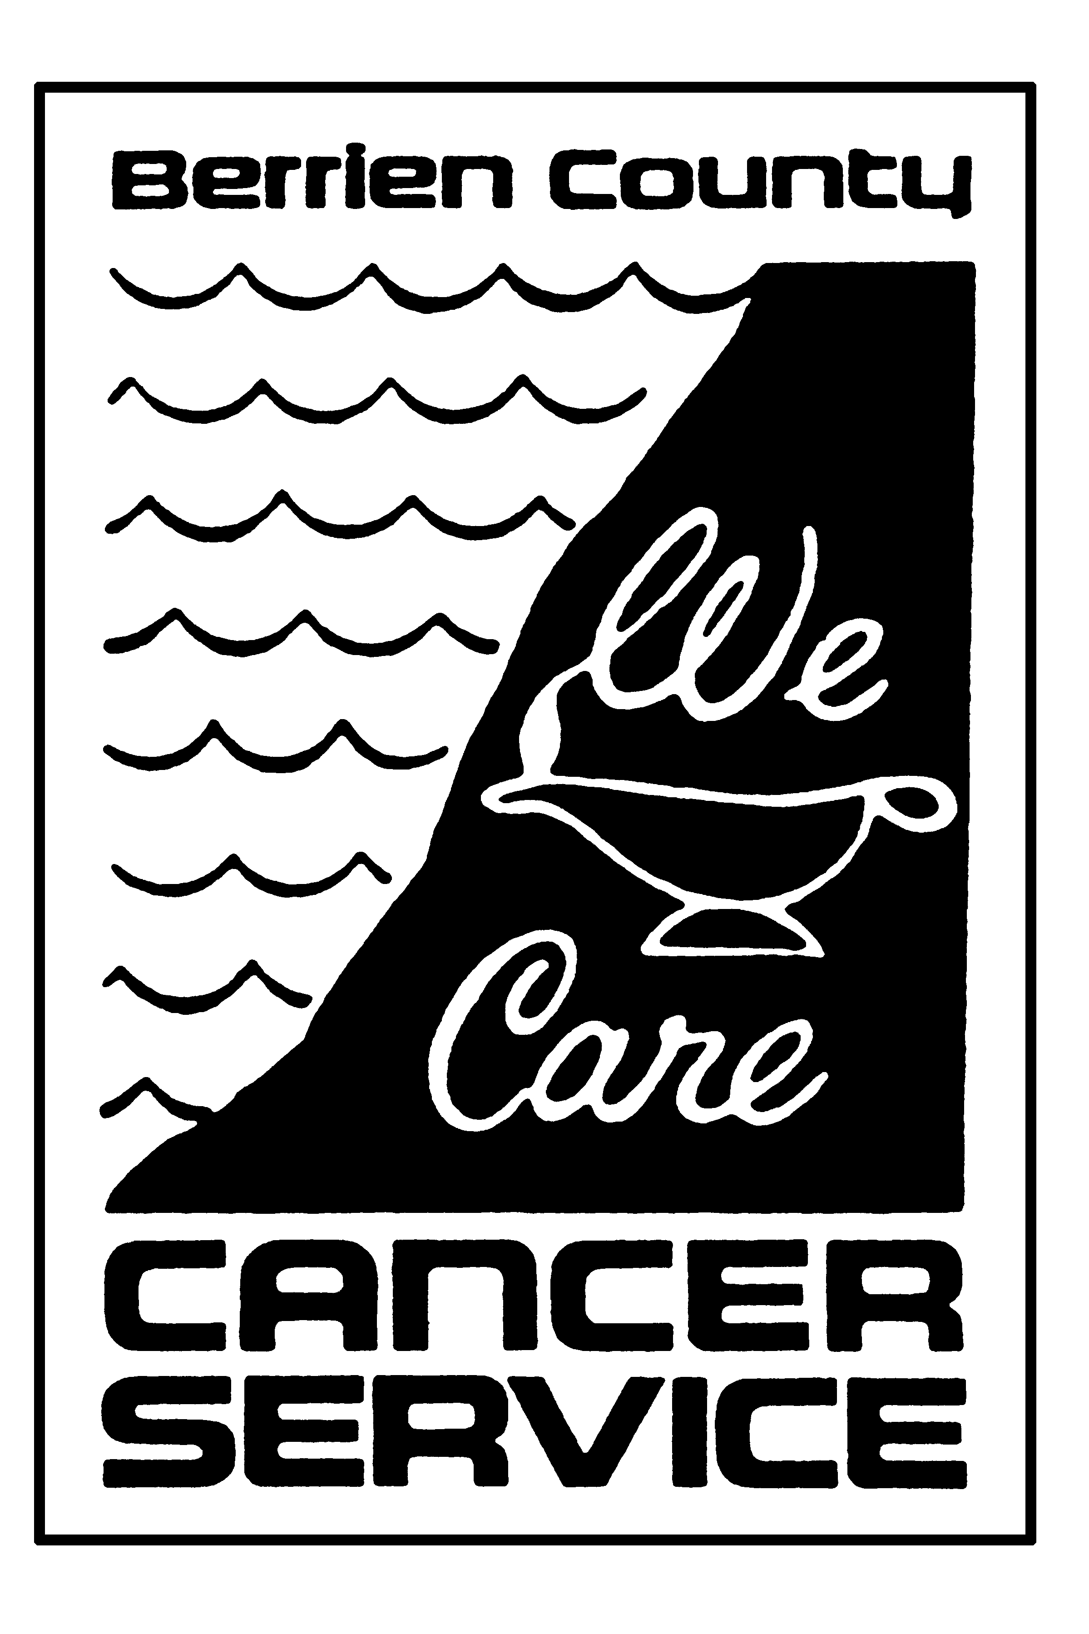**BERRIEN COUNTY CANCER SERVICE**

**NEWSLETTER**

www.bccancerservice.org

**In honor of the committed service of Olove Colcord, R.N.**

**THE MISSION OF THE** **BERRIEN COUNTY CANCER SERVICE**:

To provide compassionate in home skilled nursing care

and supportive resources for those affected by cancer

or related illnesses

in Southwest Michiga

# June 2017 (269) 429-3281 VOLUME XXIV ISSUE VI

The **BERRIEN COUNTY CANCER SUPPORT GROUP**

is a group for patients, family members and care givers. Come

share successes, feelings, fears and practical methods of coping

with the physical and emotional aspects of living with

the diagnosis of cancer.

Happy Father’s Day

 God knew that children all would need

Someone secure and strong

To shelter and protect them,

And to teach them right from wrong—

 Someone to take pride in,

And Look up to as a guide,

Someone they could count on.

And in whom they could confide—

He knew as children grew up,

They’d need the reassurance of

Someone with faith and trust in them,

Who would always give them love—

And that’s why God made fathers.

***From Metro Washington By-Pass***



**BCCS Bulletin Board**

**ART PLAY WORKSHOPS**

Our new schedule and the registration for the 2017 Art Play Workshops are in our website at www.bccancerservice.org. These art workshops are for children who are impacted by cancer and are designed to encourage expression of feelings. Our Facebook page has fun-filled photos of the workshops – check it out at Berrien County Cancer Service, Inc. If you know of any children who have a family member or close friend with cancer or are a stable pediatric cancer patient, please have the family call 269-429-3281 and speak with Nancy regarding our Art Play Workshops.

**PENNIES FOR PATIENTS – *THE POWER OF A PENNY!***

 We had a fun and eventful 28th Annual Pennies for Patients Day! The day started off with double coverage. There was the familiar voice of Pat Moody from 6:00 – 9:00 a.m. on WSJM radio giving penny facts and interviewing BCCS staff, Board Members, and Madeline Schramm whose mother is our oldest patient. Alex Elich of WSBT Channel 22 was also here to kick off the day. All day long we were greeting many of you who came bearing wonderful gifts of pennies, nickels, dimes, quarters, dollars, and checks. We will have a final count in the July newsletter. What a wonderfully caring community we live in!

**Stevensville 4 Corners**

She’s done again! Ashley Weber, our extraordinary teen volunteer organized to collect donations for Pennies for Patients Day at Stevensville’s 4 Corners. If you were driving though that intersection on Friday, April 21, you may have seen Ashley along with her family and friends including BCCS volunteers and staff. Over the past several years, Ashley has collected over $10,000.00 for BCCS!!! What an amazing volunteer!

C:\Program Files\Microsoft Office\MEDIA\CAGCAT10\j0199283.wmf**RECYCLE PAROL FUNDRAISERS**Looking for a great opportunity to get rid of unwanted items and donate to a great cause? The Recycling Patrol of Berrien County is having corded item drop off events to benefit BCCS  
**Friday July 7th from 11am-3pm at the North Berrien Senior Center in Coloma, MI   
Friday September 22nd at Lake Charter Township Hall in Bridgman, MI**   
Small and large appliances accepted. When you bring in televisions or monitors there will be a $10 fee for each one. All other corded items whether it’s 1 or a vehicle full will have a $5.00 fee. If you can't get over to the event, you can call Recycle Patrol to come pick your items up! If you have questions, contact Recycle Patrol at 269-369-1678 or email them at [recyclingpatrol@yahoo.com](mailto:recyclingpatrol@yahoo.com)  
 More information on our website: www.bccancerservice.org

**THANK YOU TO GIRLS ON THE RUN!**A BIG THANK YOU to the Countryside Academy Girls on the Run for reaching out to our patients and fundraising to support our services! They wanted to help those with cancer in our community, so they held a bake sale and raised 258.10! They also learned about our services by inviting Nancy Church, Executive Director and nurse to come talk to them about the mission of BCCS. Also, THANK YOU! to Countryside Academy teacher and Girls on the Run coach, Jessica Schoeneich, for making it happen!